**Aligning Molecular and Microscopy Methods for Biofouling Detection of Farmed Seaweed (*Alaria esculenta* and *Saccharina* *latissima*)**

**Calum Young, Konstantin Chekanov, Brendan Robertson, Eleni Christoforou, Martin Llewellyn, Maria Alguero-Muniz, Victoria Delannoy, Kyla Orr, Sofie Spatharis**

**Add potential journals: Environmental dna, Aquaculture reports,**

**Aquaculture environment interactions, aquaculture**

**Abstract**

Kelp farming in the North Atlantic is emerging as new sustainable source of food, add what else. Seaweed biofouling by epibiont taxa, including bryozoans, hydrozoans, amphipods, bivalves, and gastropods is a key constraint in kelp yield and quality. The meroplankton stages of these epibionts in the water column precedes visible settlement on seaweed fronds. Thus, the precise taxonomic detection of the meroplankton stage and the estimation of lag from the biofouling stage could act as an early warning helping farmers plan harvesting times. To achieve this, monthly samples of plankton and kelp fronds were collected from a Scottish kelp farm during a kelp farming period (September 2021-June 2022). The taxonomic identity of kelp biofouling epibionts was established by microscopy and barcoding and the taxa were then traced in the plankton samples which were analysed both by microscopy as well as eDNA metabarcoding. Taxonomic identification of kelp epibionts via COI barcoding agreed with microscopy findings in 13 out of 16 specimens and helped refine the taxonomic resolution from family and genus down to species level. Out of the 14 epibiont species identified from the kelp fronds, 9 were identified via microscopy at phylum, class or genus level and 8 were identified via eDNA metabarcoding at species level. Microscopy counts of Hydrozoan medusae, Bryozoan cyphonautes and Bivalve larvae peaked in the plankton two weeks before the maximum coverage on Saccharina fronds. Maxima of eDNA reads and microscopy abundances did not coincide temporally for the same taxa. Depth-stratified blade surveys showed that kelp segments that were deeper in the water column harboured the highest hydrozoan infestation, indicating either depth-related colonisation processes, kelp age-related exposure effects or UV avoidance. The results indicate that the combination of molecular diagnostics and conventional light microscopy improves the sensitivity and specificity of biofouling detection, facilitating earlier and more informed farm management decisions.

Keywords: biofouling, environmental DNA, kelp aquaculture, early warning, epibionts, COI marker

**Introduction**

Kelp cultivation in the North Atlantic coasts is currently rapidly expanding due to its potential for high-value nutritional, medical, agricultural and industrial products while mitigating climate change and enhancing coastal ecosystem services (Jagtap and Meena, 2022, Duarte et al., 2023, Sultana et al., 2023). With plans to increase production to 8 million tonnes by 2030, seaweed farming is critical to the EU’s sustainable blue economy aiming to create 85,000 jobs and generate an estimated 9 billion Euros of revenue (Jueterbock et al., 2025). However, a major limitation to the commercial viability of the industry is the damage incurred at latter stages of kelp growth by biofouling epibionts such as bryozoans, hydrozoans, bivalves, gastropods, amphipods, tunicates and epiphytic algae (Matsson et al., 2019, Visch et al., 2020, Bannister et al., 2019). Most biofouling taxa colonise kelp as larvae that settle from the water column at their meroplankton stage (ref) and . Therefore, precise taxonomic identification and understanding of the temporal dynamics of biofouling epibionts in the water column is an important step towards a kelp biofouling early warning system that can help farmers fine tune optimal harvest times.

The cold, mesotrophic waters of the North-East Atlantic are ideal for macroalgal cultivation but also offer optimal conditions for seasonally proliferating epibionts (Forbord et al., 2020). Fouling organisms compromise kelp fronts in three major ways: through physical damage, physiological disruption, and competition for vital resources (Bannister et al., 2019). Encrusting and sessile species such as bryozoans and hydrozoans reduce light penetration, hinder nutrient and gas exchange, and block reproductive spore release which can collectively lead to tissue necrosis (Walls et al., 2017). Biofouling reduces frond flexibility and increases hydrodynamic drag leading to breakage and detachment in higher wave-exposed environments (Krumhansl et al., 2011). As infestation severity increases, the quality, taste, and market value of the crop declines leading to rising processing costs and allergen risks for consumers (Walls et al., 2017, Bannister et al., 2019). To avoid peak biofouling, farmers are often forced to harvest earlier than peak kelp biomass is achieved, thus sacrificing yield volume and profitability (Visch et al., 2020).

The meroplankton stage of biofouling taxa is vital because it allows epibionts to disperse throughout the water column before settling on a suitable substrate such as the kelp fronds. Bryozoan species such as *Membranipora membranacea* release dispersing larvae called cyphonautes from already established overwintering colonies These larvae can remain in the water column for months before finally settling and establishing themselves (Ryland, 1962). In contrast, hydrozoan dispersal occurs via release of medusae or planula larvae from either benthic polyp or pelagic stages of surrounding fouling communities (Martell et al., 2018). Bivalves such as *Mytilus sp.* and *Hiatella arctica* produce planktonic veliger larvae during synchronous spawning events that drift from nearby rocky shores, shellfish beds or aquaculture structures themselves (Garcia et al., 2003, Delannoy et al., 2025). To understand and reduce the biofouling risk caused by epibionts, it is crucial to identify the abundance that each biofouling taxon is present in the water column at its meroplankton stage. However, because their identification at species level is almost impossible in the meroplankton phase, molecular approaches could help correspond the taxonomic identity between epibionts on kelp and meroplankton on the water column.

Metabarcoding amplified targeted barcode regions of environmental DNA (eDNA) from seawater samples could enable early detection of epibiont communities by identifying genetic material shed in the water medium by organisms (ref). Because this is a highly sensitive method, taxa can often become detectable via eDNA but be missed by microscopy (Zaiko et al., 2016, Djurhuus et al., 2017). In the context of biofouling eDNA could potentially enable early detection of epibiont presence in the meroplankton weeks before colonisation may become visible on the kelp fronds (Keck et al., 2022, Rishan et al., 2023). A commonly used marker in marine metazoan metabarcoding is the mitochondrial cytochrome c oxidase subunit I (CO1) gene, which provides species-level resolution for many invertebrates (Borrell et al., 2017). However, with metabarcoding, challenges remain with taxonomic gaps and detection inconsistencies, particularly in low abundance species due to amplification biases caused by primer selectivity (Algueró‐Muñiz et al., 2024). By aligning molecular reads with visual observations such as planktonic counts and blade colony assessments, it becomes possible to generate a more holistic understanding of biofouling dynamics and a generate comprehensive framework detailing biofouling communities’ emergence, development and peaks throughout the seaweed production season.

The aim of this study was to assess a combination of molecular methods (plankton eDNA and epibiont barcoding) and microscopy methods (kelp epibiont and plankton counts) in better understanding the timing and community composition of biofouling. To achieve this aim, we sampled a farm of *Saccharina latissima* and *Alaria esculenta* for plankton and epibiont species composition during a whole production cycle. Our first objective was to obtain a high resolution taxonomic ID of the kelp epibionts using a combination of microscopy and barcoding. The second objective was to assess if the epibionts could be detected in the plankton and to evaluate whether the taxonomic sensitivity of eDNA metabarcoding and microscopy align in detecting seasonal patterns in abundance. Our third objective was to check for lags between the timing that kelp epibiont taxa are detected in the plankton (by both eDNA and microscopy) and when these appear as adult stages on the kelp. Finally, we checked for potential effects of depth on the distribution of epibionts on kelp front sections.

**Methods**

*Methods overview*

We combined eDNA metabarcoding, plankton‐net microscopy counts, and visual surveys of kelp biofouling epibionts to undertake both descriptive and comparative analyses addressing three core objectives (Fig.1): 1) Method comparison: Quantify and contrast the sensitivity and taxonomic resolution of molecular (eDNA metabarcoding, barcoding) versus microscopy‐based approaches in detecting epibionts both in the water column and on kelp fronds. 2) Temporal dynamics: Characterize time‐lags among epibionts in meroplankton detected by eDNA and microscopy, and the subsequent identification of adult forms on kelp fronds. 3) Depth dependent distribution: Evaluate how epibiont prevalence varies between base section of the frond (shallowest) and tip (deepest).

*Figure 1. Methodological Framework integrating molecular and microscopy approaches to study bla bla: Overview of the study approach and objectives. Explain the second generation*

*Study site and sampling*

Between September 2021 and July 2022, the Pabay site within the ®KelpCrofters seaweed farm (NW Scotland) was sampled. This allowed for an end-to-end comparison of kelp production cycles for two different kelp species (*S. latissima and A. esculenta*), spanning a total of 18 sampling days. Samples were collected from 3 GPS points () as replicates across the whole sampling period. At each GPS point, samples of zooplankton, eDNA and epibionts were collected as described below.

*Zooplankton and Microscopy*

The zooplankton community was sampled using vertical net haul at each of the three stations, using an Apstein net (40cm diameter, 55µm mesh size) equipped with a closed cod end. The tow sampled the water column vertically from 10 m depth for a total volume of 491 L. Samples were rinsed on site with pre-filtered seawater, collected in containers, and fixed with buffered 40% formaldehyde solution for preservation.

During microscopy observation, organisms were sorted using a stereomicroscope (Leica S9i) and classified to the highest resolution possible. Counts recorded all taxa but were focused on meroplanktonic stages of epibiont taxa for greater taxonomic resolution.

*Epibionts: morphological and molecular identification*  
  
here you need to say when we sampled ropes and when we started to have actual data from fronts. Explain where we have gaps and why. When harvesting occurred. When seeding took place. For sugar kelp we have two generations, kyla needs to supply the seeding dates. Kelp from July correspond to the later generation. Fronds were collected at each of the three stations and were preserved within volume plastic containers in 95–100% ethanol, and stored at –20 °C until analysis. Mention replicates per station and segments(tip middle base).  
  
Before processing, samples were brought to room temperature and handled under sterile conditions. Non-sessile organisms were recovered by sieving, and fronds were rinsed with ethanol. Each frond was photographed to estimate fouling cover, and attached specimens were removed with sterile forceps. Specimens were identified morphologically under a stereomicroscope (Leica S9i), photographed, and preserved for molecular analysis. Abundance of each taxon per frond was estimated under the stereomicroscope. To confirm and refine identifications, selected speciments were subjected to DNA barcoding.  
  
DNA extraction was performed using Qiagen DNeasy® Blood & Tissue Kit protocol with minor adjustments. Individual specimens were placed in 2 mL centrifuge tubes, treated with Buffer ATL, and gently pressed with a sterile ball-point tool before the addition of Proteinase K. Samples were incubated at 56 °C for 1 h, and the remaining steps of the Quick-Start Protocol were followed with elution in 150 µL Buffer AE. DNA yields were quantified by NanoDrop or Qubit™ Fluorometer; samples exceeding 20 ng/µL were diluted to ~1.3 ng/µL and used for PCR amplification. PCR products were checked by gel electrophoresis, purified with the Invitrogen PureLink® PCR Purification Kit and then submitted to Sanger sequencing (University of Dundee).  
  
Sequences were trimmed and aligned using BioEdit Sequence Alignment Editor and taxonomically assigned using BLAST searches against the NCBI GenBank database. A threshold of ≥97% sequence similarity, amplicon length >80 bp, and the lowest E-value was applied for species designation. Sequences not meeting these criteria were omitted.

*Planktonic Environmental DNA (eDNA)*

Environmental DNA was extracted from seawater samples collected at the seaweed cultivation sites. A Niskin bottle was used to collect 5 L of seawater at 5 m depth. The water was transferred into a handheld sprayer pump adapted to hold two output tubings fitted with 0.2 µm Sterivex filters (Merck), allowing filtration of 500 mL seawater per filter. Filters were then air-dried and stored individually in 50 mL sterile centrifuge tubes at 4 °C until extraction.

DNA extraction was carried out using the Qiagen DNeasy® Blood and Tissue Kit following the manufacturer’s Quick-Start Protocol with minor modifications. 500 µL of lysis buffer and 50µL of Proteinase K was added to each filter before being sealed on both sides and incubated overnight at 56 °C on a rotary wheel (~150 rpm). The lysate was then transferred to 2 mL centrifuge tubes and mixed with 500 µL AL buffer and 500 µL absolute ethanol. Solution was transferred in parts to a spin-column and centrifuged at 15,000 xg (1min) until all was used. 500 µL of AW1 wash buffer was added, and spun again at 15,000g (1min). 500 µL of AW2 wash buffer was then added, and spun again at 15,000g (2min). Wash buffers were discarded after each spin. Spin-columns were then spun with no buffer (15,000 xg for 1 min) to remove remaining trace ethanol. Finally, 55 µL of AE elution buffer was added to the spin-column, this was left for 5 minutes to incubate at room temperature before a final centrifuge into a collection Eppendorf (10,000 xg for 2 min). Sample purity and concentrations were tracked via Nanodrop and Qubit analysis, respectively.

Extracted DNA was amplified using a two-step PCR protocol that targeted mitochondrial cytochrome c oxidase subunit I (COI) gene. The first PCR used 10 µL polymerase master mix, 1 µL each of forward and reverse primers, 0.16 µL bovine serum albumin, 5.84 µL molecular-grade water, and 2 µL DNA extract. Thermocycling conditions were: 95 °C for 5 min; 35 cycles of 95 °C for 1 min, 55 °C for 1 min, 72 °C for 1 min; and a final extension at 72 °C for 5 min.

The second PCR used internal barcoding primers, and a reaction mix of 2.5 µL barcode (red plate), 8.7 µL H₂O, 12.5 µL Q5 polymerase, and 1.3 µL first-round PCR product per sample. Amplification products were checked by gel electrophoresis, purified using the Invitrogen PureLink® PCR Purification Kit, and submitted for Sanger sequencing.

*Data analysis*

Data analysis was performed in R (v4) using the *tidyverse* framework for data wrangling and transformation. Plankton abundances, blade coverage, and eDNA read counts were standardised and log-transformed when deemed necessary. Heatmaps of seasonal dynamics temporal patterns of plankton abundances were produced using ggplot2 package. Generalised linear models (GLMs) were used to test the effect of depth on the prevalence of epibionts on fronds. More…GAM on the dynamics of zooplankton

**Results**

*Barcoding analysis for the detection of kelp epibionts on the fronds*

DNA barcoding greatly improved the taxonomic resolution of epibiont identifications, relative to traditional microscopy. Table 1 shows several taxa which were not confidently identified above the taxonomic level of order during visual surveys but were successfully identified to species level using barcode sequencing. For example, *Caprella mutica* and *Jassa herdmani* were both confidently identified with 100% sequence identity, while microscopy was unable to distinguish them beyond the broader taxonomic group. Similarly, hydrozoan taxa such as *Ectopleura larynx*, *Bougainvillia muscus*, and *Clytia hemisphaerica* were all allocated to species level by barcoding despite being recorded only as “Hydroid” or left unclassified in microscopic observations of plankton and fronds.

Several barcoded taxa including *Caprella mutica*, *Jassa herdmani*, *Hiatella arctica*, *Ectopleura larynx*, and *Bougainvillia muscus* were also recorded from rope scrubs, indicating that these species may establish on farm infrastructure prior to kelp blade development. Furthermore, the key epibiont species; *Electra pilosa*  was confirmed from ropes via barcoding, supporting the interpretation of rope colonisation as a precursor to blade settlement.

*Table 1. Summary of epibiont taxa identified and the highest taxonomic resolution achieved by each method: visual identification from fronds, planktonic microscopy surveys, COI metabarcoding and DNA barcoding of individuals sampled from fronds. Percentage value (%) denotes the percentage identity match of the sequence with with GenBank database. Rope scrub presence (Y/N) denotes taxa identification from scrubbing of farm ropes prior to seaweed seeding.*

|  |  |  |  |  |  |
| --- | --- | --- | --- | --- | --- |
| Epibiont ID from kelp frond: Microscopy | Epibiont ID from plankton:  Microscopy | Epibiont ID from kelp frond:  Barcode ID | Epibiont ID from plankton:  Metabarcoding ID | Epibiont Rope Scrub Presence | Photo |
| Amphipoda (Caprellidae) | NA | *Caprella mutica* (100%) | NA | Y |  |
| Amphipoda (Caprellidae) | NA | *Jassa herdmani* (100%) | *Jassa herdmani* | Y |  |
| Amphipoda (Jassa) | NA | *Jassa herdmani* (100%) | *Jassa herdmani* | Y |  |
| Bryozoans (cf Celleporella hyalina) | Cyphonaute | *Celleporella hyalina* (98.79%) | *Celleporella hyalina* | N |  |
| Clam juvenile | Bivalvia | *Hiatella arctica* (97.7%) | NA | Y |  |
| Dendronotid sea slug (Doto) | Gastropod | *Doto coronata* (99.62%) | *Doto coronata* | Y |  |
| Electra pilosa | Cyphonaute | *Electra pilosa* (97.3%) | *Electra pilosa* | Y |  |
| Hydroid (Tubulariidae) | NA | *Ectopleura larynx* (100%) | *Ectopleura larynx* | Y |  |

|  |  |  |  |  |  |
| --- | --- | --- | --- | --- | --- |
| Epibiont ID from kelp frond: Microscopy | Epibiont ID from kelp frond: Barcode ID | Epibiont ID from plankton - Microscopy | Epibiont ID from plankton:  Metabarcoding ID | Rope Scrub Presence | Photo |
| Hydroid (with Licmophora attached) | *Clytia hemisphaerica* (99.59%) | Clytia sp. | *Clytia sp. 1/2* | Y |  |
| Hydroid (with Licmophora diatoms attached) | *Bougainvillia muscus* (99.41%) | NA | *Bougainvillia muscus* | Y |  |
| Membranipora membranacea | *Membranipora membranacea* (99.60%) | Cyphonaute | *Membranipora membranacea* | N |  |
| NA | *Amphibalanus improvisus* (100%) | Balanoid nauplii | NA | N |  |
| Obelia sp. | *Obelia dichotoma* (99.67%) | Obelia sp. | *Obelia dichotoma* | N |  |
| Rhodophyta (Pterosiphonia spinifera) | *Pterothamnion plumula* (98.86%) | NA | NA | Y |  |
| Unidentified | *Laminariocolax tomentosoides / Ectocarpus deformans or*  *Hincksia granulosa /* ***Hincksia hincksia*** | NA | NA | Y |  |
| Hydroid Hydroid (with Licmophora diatoms attached) | *Bougainvillia muscus* (99.41%) | Hydroid | *Bougainvillia muscus* | Y |  |

*Alignment of eDNA and microscopy in detecting meroplanktonic kelp epibionts*

Taxonomic identification of kelp epibionts via COI barcoding agreed with microscopy results in 13 out of 16 specimens but further enhanced their taxonomic resolution from family and genus down to species level. Out of the 14 epibiont species identified from the kelp fronds, 9 were identified via microscopy at phylum, class or genus level and 8 were identified via eDNA metabarcoding at species level. Microscopic analysis showed meroplankton peaks in Hydrozoans, Bryozoans and Bivalves two weeks before maximum coverage was observed on *Saccharina* fronds. However, for the same epibiont taxa, temporal maxima of eDNA reads and microscopy abundances partially coincided. Bryozoan eDNA reads peaked in late November, whereas cyphonaute abundance did not peak until July (Fig. 2). For Hydrozoa, peak eDNA reads were observed in February 2021 (as *Clytia* sp. 2) whereas plankton microscopy counts identified as Obelia did not peak until late June (Fig. 3). In Bivalvia, *Kurtialla bidentata* and *Dosinia sp,* showed the highest eDNA reads in May and late June, respectively. This preceded the mid-July peak of bivalve larvae observed via microscopy which was only identified at class level (Fig. 4).

*Bryozoa*

Microscopic analysis and barcoding of bryozoans extracted from kelp, identified three species: *Celleporella hyalina, Electra pilosa* and *Membranipora membranacea* (Table 1). These species were also identified from plankton eDNA. The autumn/winter peak of cyphonautes, recorded at phylum level from microscopy counts, coincided with the peak of eDNA reads of *M. membranacea* and *E. pilosa*. The mid July peak of cyphonautes did not coincide with an eDNA signal, but did supercede the visual appearance of *C. hyalina, E. pilosa* and *M. membranacea* on the fronds in late July.

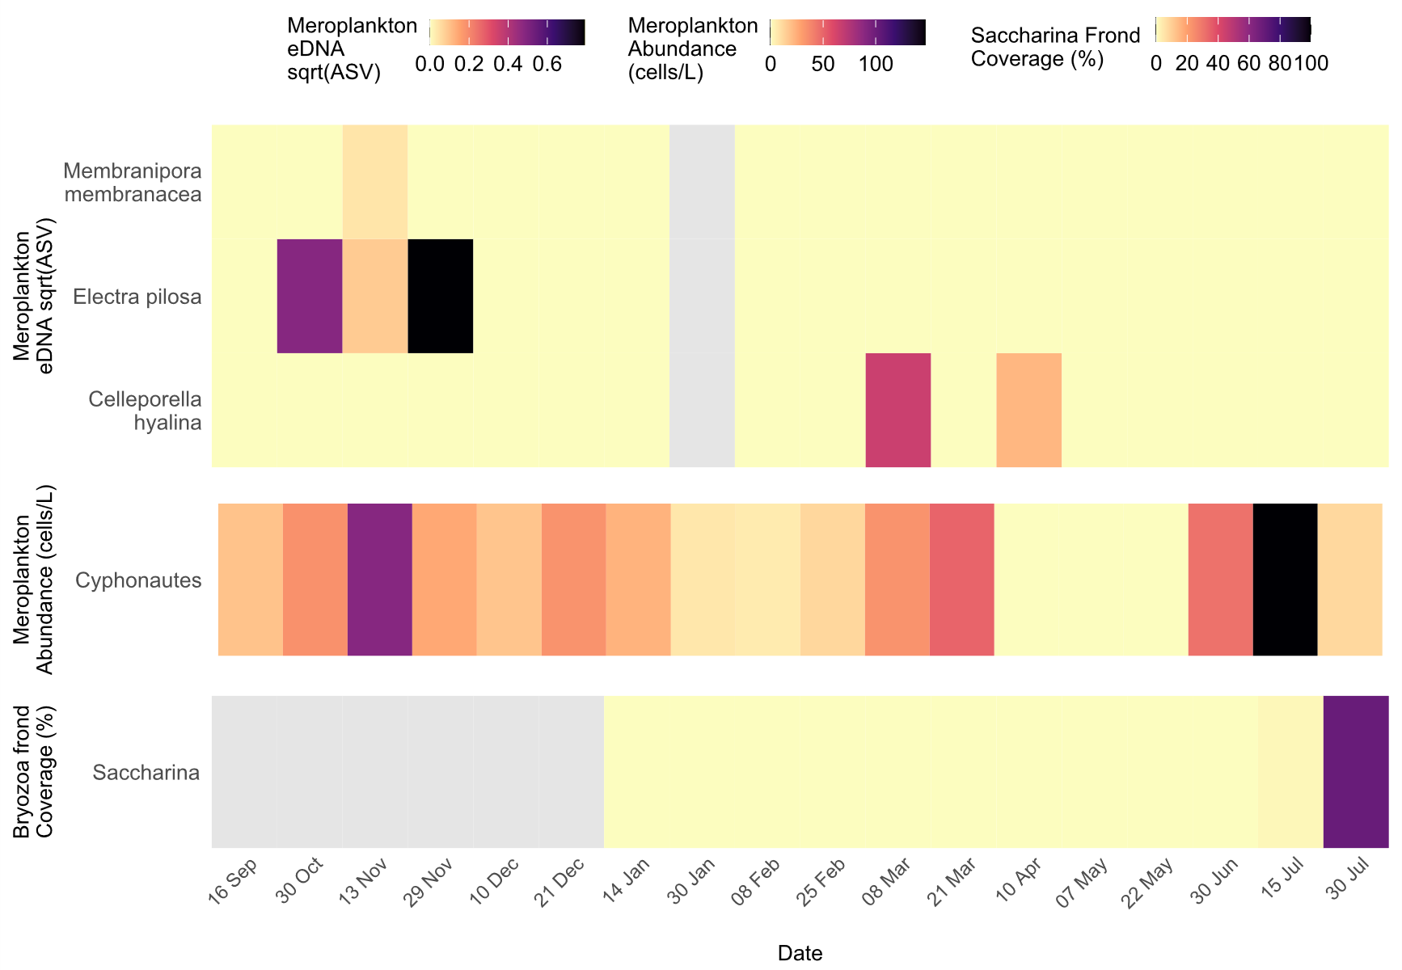

*Figure 2. Temporal dynamics of Bryozoa epibionts. Heatmaps showing the seasonal patterns of bryozoan detection by eDNA metabarcoding, plankton microscopy, and blade settlement on cultivated kelp. Colours indicate sqrt-transformed amplicon sequence variant (ASV) abundances (%), plankton cell counts (cells/ L); and percent coverage (%) of bryozoan colonies on Saccharina fronds. No blade detection of bryozoan species were recorded on Alaria. Sampling dates span 15 Jun 2021 to 30 Jul 2022. All values are monthly averages calculated from three independent replicate samples per date. Grey shading marks data unavailable.*

*Hydrozoa*

From the 5 hydroid specimens isolated from kelp fronds, only 1 was identified via microscopy as low as genus level (*Obelia* sp.)(Table 1). COI barcoding identified the exact species of Obelia as *O. dichotoma* whereas it also classified the other 4 specimens as *Ectopleura larynx, Bougainvillia muscus and* *Clytia hemisphaerica* (Table 1). Hydrozoans in plankton counts were detected at genus level as Obelia showing a distinct seasonal rise in May with a peak in late June. In total, the molecular dataset identified 25 hydrozoan taxa at the genus or species level, with *Bougainvillia muscus* and *Clytia spp.* among the most prominent showing broadly within eDNA throughout November 2021 to July 2022 (brief dropouts in December and February) and the highest overall peak in early February. Both *Bougainvillia muscus* and *Clytia sp. 2* exhibited strong eDNA signals in March–April, preceding the rise in plankton abundance and peak blade colonisation on *Saccharina* where mean coverage rose steeply in June and reached its maximum in mid-July (~30%). Alaria exhibited substantially lower levels of colonisation, with the average only peaking at ~3% coverage in early July.

Additional taxa, including *Ectopleura larynx* and *Obelia dichotoma*, were detected sporadically in March–May, while faint winter detections of *Obelia bidentata* (December–February) did not correspond with blade or plankton counts, suggesting early-stage presence or low-density overwintering cohorts below the threshold of visual detection.

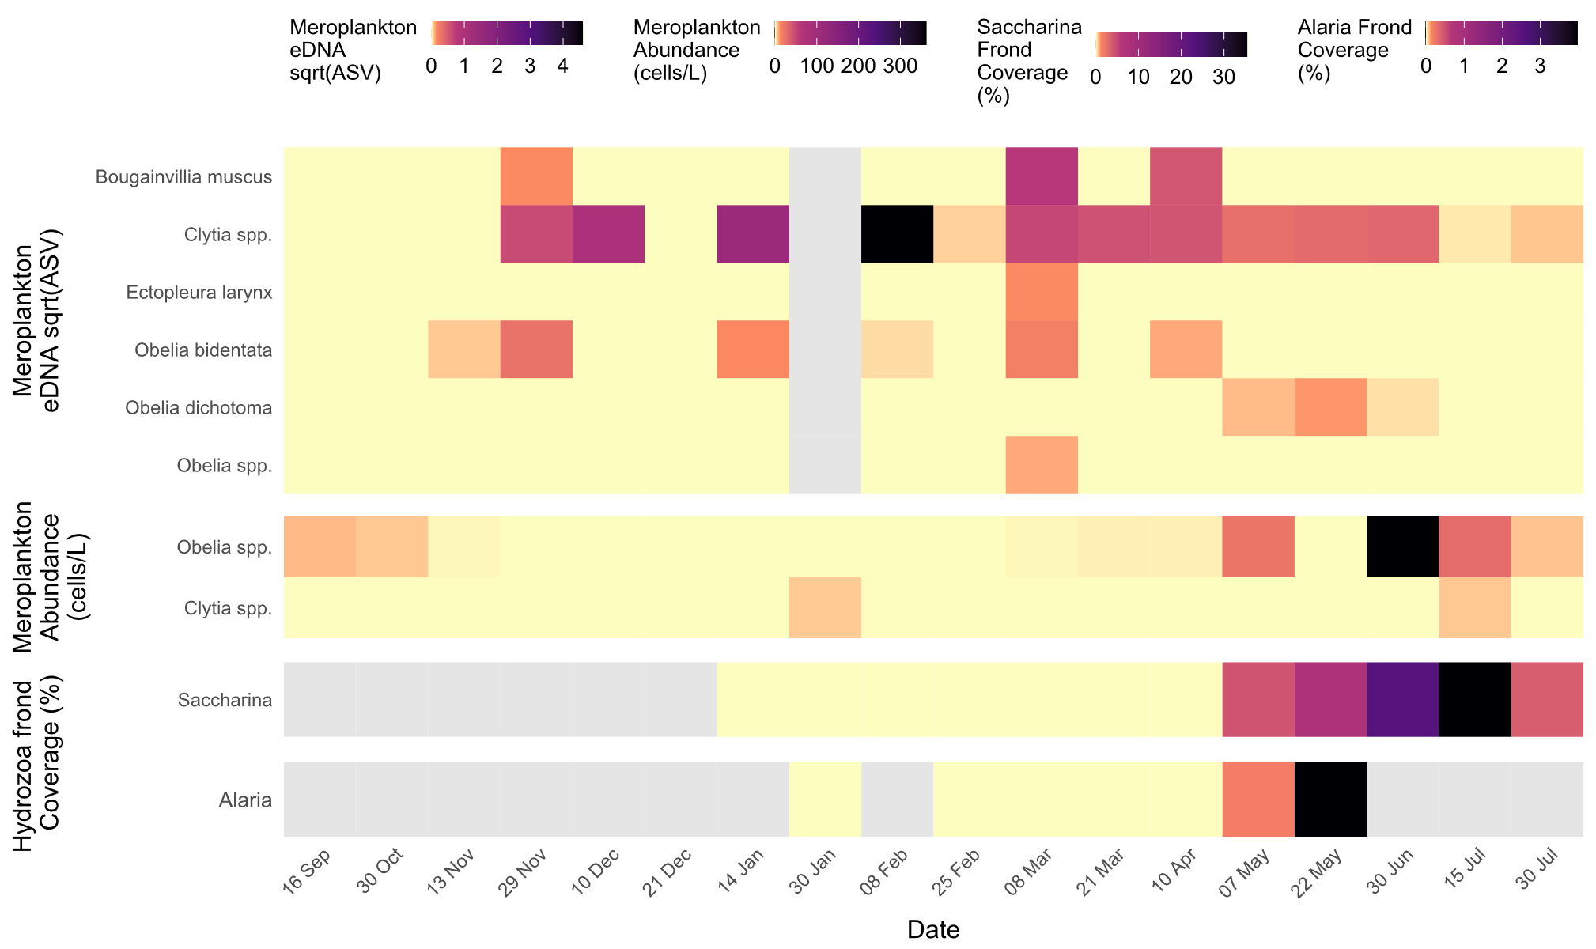

*Figure 3. Heatmaps showing the emergence and settlement of Hydrozoa detected by eDNA metabarcoding, plankton microscopy, and blade fouling on two kelp hosts. Colour intensity represents sqrt transformed relative abundance of amplicon sequence variants from eDNA read samples, plankton abundances (cells/ L); and percent blade coverage (%) measured separately on Saccharina and Alaria. Sampling dates span 15 Jun 2021 to 30 Jul 2022. All values are monthly averages calculated from three independent replicate samples per date. Grey shading marks data unavailable.*

*Bivalvia*

4 different genera of bivalve juveniles (*Mytilus*, *Pecten, Ostrea, Aequipecten*) were identified via microscopy from the kelp fronts whereas an extra species that was rare was identified via COI barcoding as *Hiatella arctica* (Table 1). However, from these 4 biofouling genera, only Mytilus was observed from eDNA metabarcoding. Bivalves peaked on Saccharina fronds in late July 22’, and this followed a peak of meroplankton bivalve counts (identified at class level) two weeks before. In contrast, *Alaria* supported minimal colonisation, with peak densities remaining below 0.004 ind/cm². However, bivalve settlement on *Alaria* was detectable from March through May when this species was harvested.

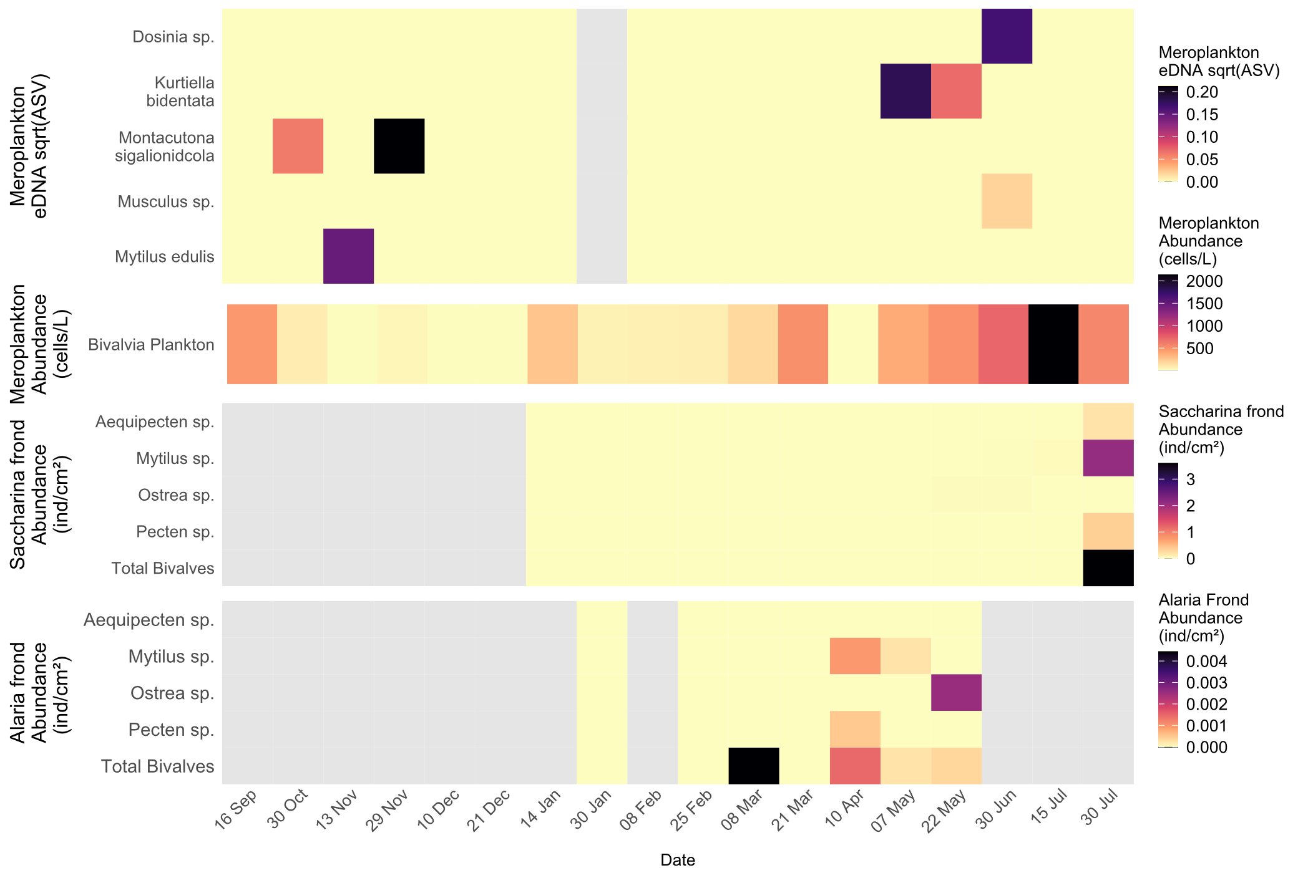

*Figure 4. Heatmaps illustrating bivalve detection and colonization over time by relative abundance of eDNA (ASV) in the water column, plankton microscopy counts (cells/ L), individual density (ind/cm²) on Saccharina fronds, and individual density on Alaria fronds. All values are monthly averages calculated from three independent replicate samples per date. As before, sampling dates run from mid-June 2021 to end-July 2022, and grey bars indicate periods without data.*

*Amphipoda*

Kelp fronds harboured three amphipod specimens of which two were identified to the family Caprellidae and one to the genus *Jassa*. COI barcoding confirmed the *Jassa* specimen and one Caprellidae sample as *Jassa herdmani*, while reassigning the second Caprellidae specimen from family-level to *Jassa herdmani*. *J. herdmani* was the only species found in congruence within the metabarcoding dataset. Plankton microscopy counts only achieved detection to the amphipod order so these espceific species were not isolated. In contrast, eDNA metabarcoding resolved three distinct amphipod taxa in the water column: *Jassa herdmani*, *Aora gracilis*, and *Niphargus arbiter (Fig. 5)*. Similar to bivalves, peaks in eDNA signals (April: *J. herdmani*) preceded planktonic count maximas (May); which both occurred earlier than *Saccharina* peak blade abundances (July). *Alaria* harboured considerably lower abundances of amphipods, but settlement occurred months earlier (*Fig. 5).*

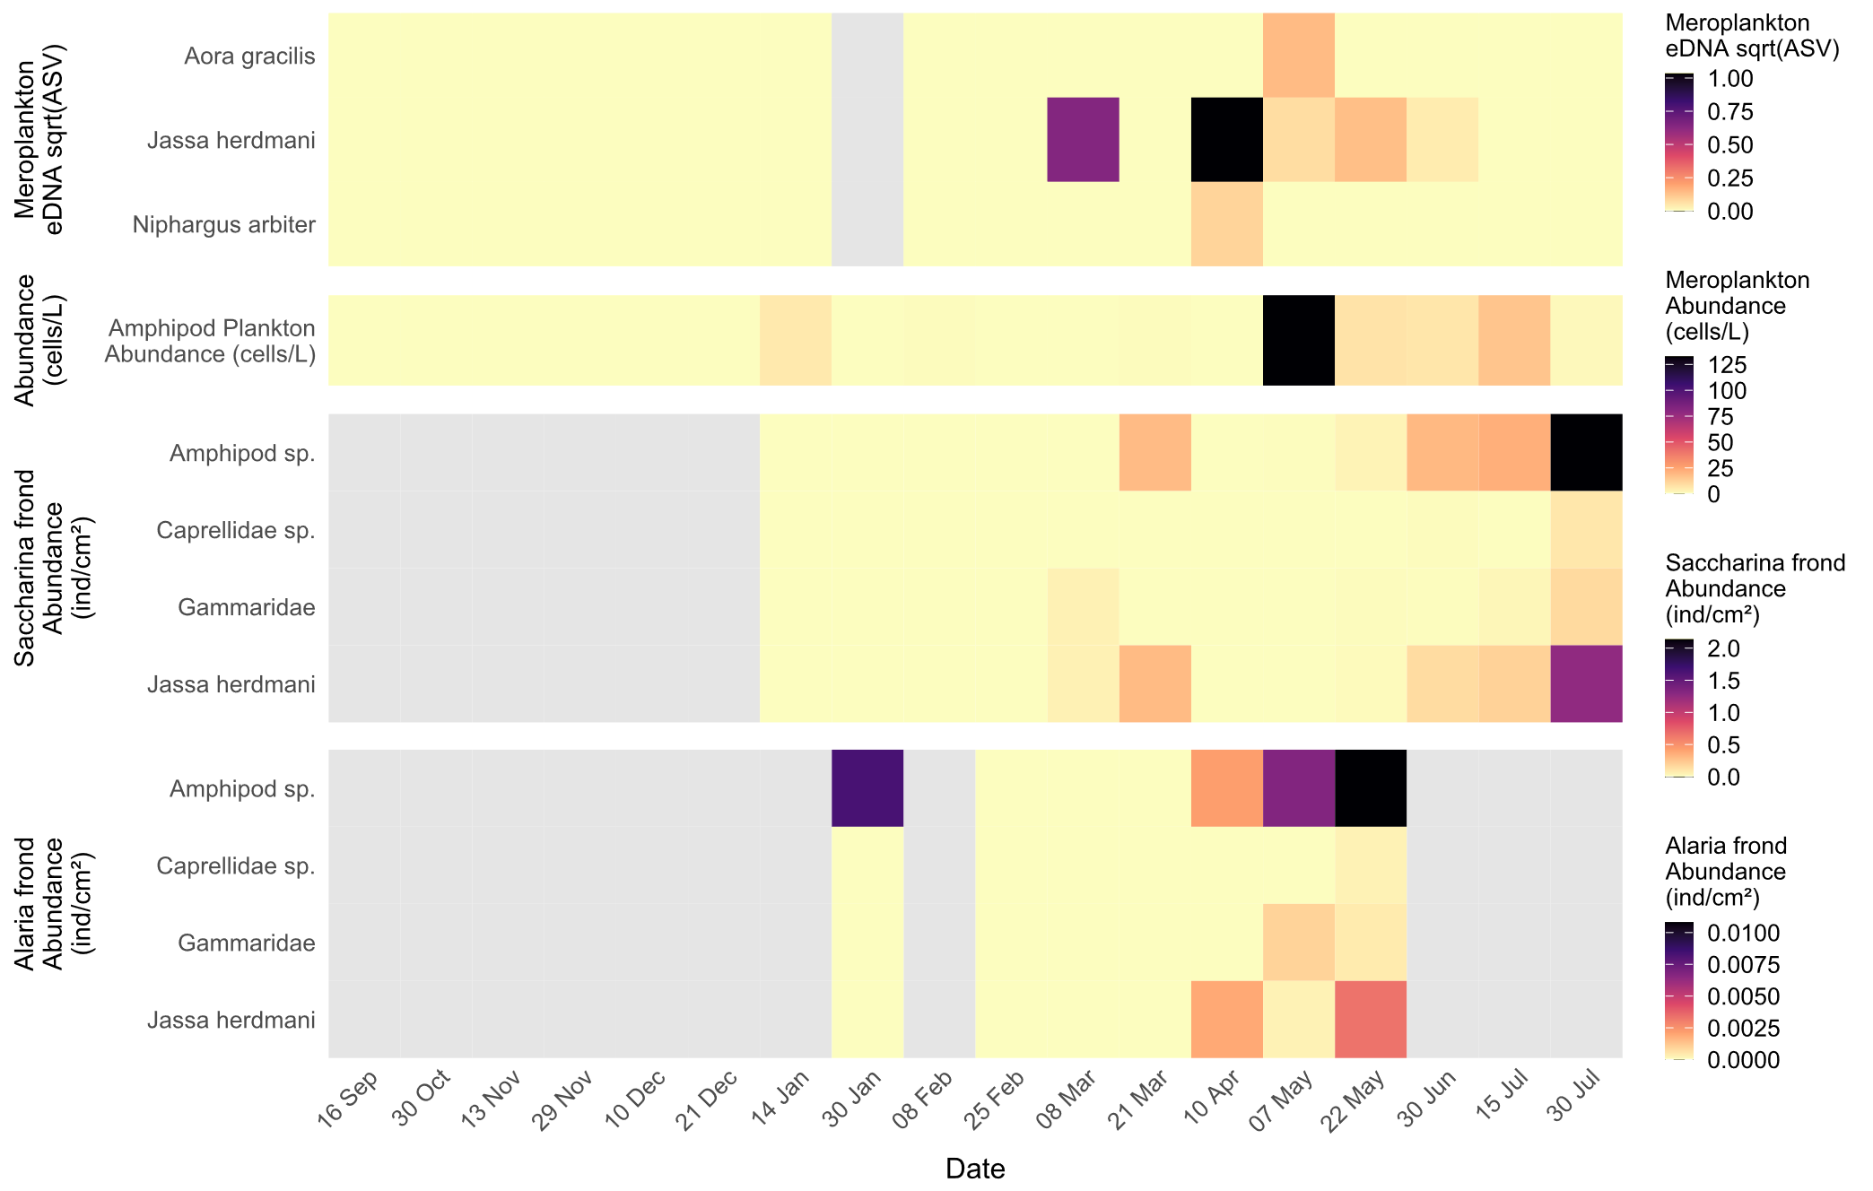

*Figure 5. Heatmaps representing seasonal patterns of amphipod detection and settlement by eDNA metabarcoding (ASV), plankton‐net microscopy counts (cells/L), and blade colonization abundance (individuals/cm²) on Saccharina and Alaria fronds. All values are monthly averages calculated from three independent replicate samples per date. Sampling dates span mid-June 2021 to late-July 2022, and the grey-shaded areas mark indicate periods without data.*

*Gastropoda*

Blade analysis recovered one gastropod specimen which identified to genus level by microscopy and further resolved to species by barcoding (*Doto coronata*) (Table 1). eDNA metabarcoding provided further species-level identifications of 22 unique gastropod taxa, including *D. coronata*. Gastropod larvae were consistently detected by microscopy throughout the study period (Fig. 6), with a prominent peak in September 2021 reaching over 800 cells/L, the highest recorded for these taxa. Despite sustained presence in the plankton, microscopy was limited to class-level identification and showed not distinct alignment eDNA reads.

*Lacuna* sp. was identified on both *Saccharina* and *Alaria* fronds (Fig. 6). Initial blade detections occurred in January on *Alaria*, followed by a clearer peak in May. On *Saccharina*, colonisation was observed later, peaking in July. These blade settlement patterns came after a strong eDNA signal for *Lacuna vincta* detected in March, suggesting a lag between larval presence in the water column and physical colonisation. *Alaria* supported earlier but lower-density settlement, peaking below 0.016 ind/cm² in May, while *Saccharina* showed later colonisation by *Lacuna* and *Rissoa* spp. in late June and July. These later settlement events on *Saccharina* were preceded by eDNA detections in April–May.

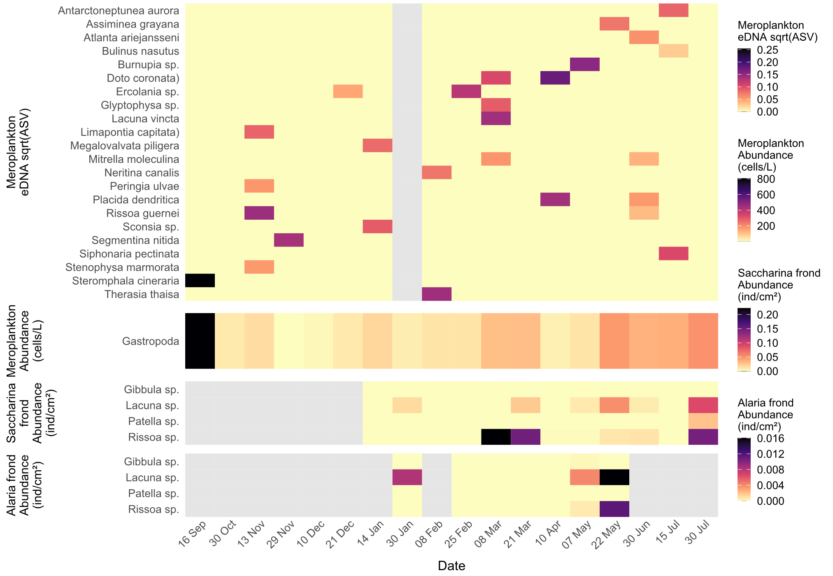

*Figure 6 Heatmaps illustrating seasonal emergence and settlement of gastropods detected by eDNA metabarcoding (ASV), planktonic abundance (cells/L), and blade settlement abundance (individuals cm⁻²) on Saccharina fronds. All values are monthly averages calculated from three independent replicate samples per date. Sampling dates run from mid-June 2021 through late-July 2022, and grey shading denotes periods without data.*

*Temporal Composition of dominant zooplankton taxa*  
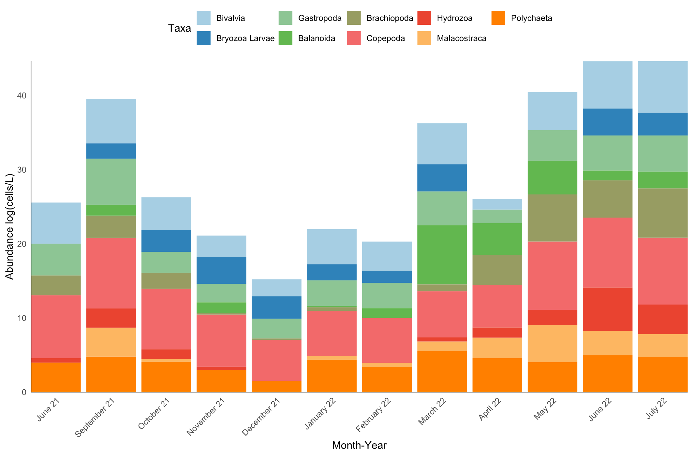

*Figure 7. Stacked bar chart showing the mean monthly log-transformed abundances (cells/ L) of the principal planktonic groups collected by 10m vertical plankton tow from June 2021 through July 2022 from Pabay, Isle of Skye.*

Figure 7 depicts pronounced seasonal variation in both abundance and composition of dominant zooplankton groups in monthly seawater samples from Pabay, Isle of Skye, between June 2021 and July 2022. Community structure shifted markedly over the sampling period with fluctuations in total abundance (log-cells L⁻¹) driven by successive dominance of different taxonomic groups.

In summer 2021 (June - September), overall zooplankton abundance was high and dominated by copepods, bivalve larvae, and gastropods, with notable contributions from polychaetes and brachiopods. Autumn (October–November) saw a decline in total abundance, driven largely by reductions in copepods and hydrozoans, although bryozoan larvae and malacostracans became more prominent.

Winter months (December - February) were characterised by the lowest overall abundances, with a more even distribution among taxa and smaller contributions from polychaetes and brachiopods. From March 2022 onward, a marked spring/summer increase was evident, with sequential peaks in copepods, bivalves, and gastropods, accompanied by rising hydrozoan abundance in late spring.

By June/July 2022, bivalve larvae reached their highest recorded levels, coinciding with elevated hydrozoan and bryozoan counts.

*Biofouling blade coverage of Alaria and Saccharina*

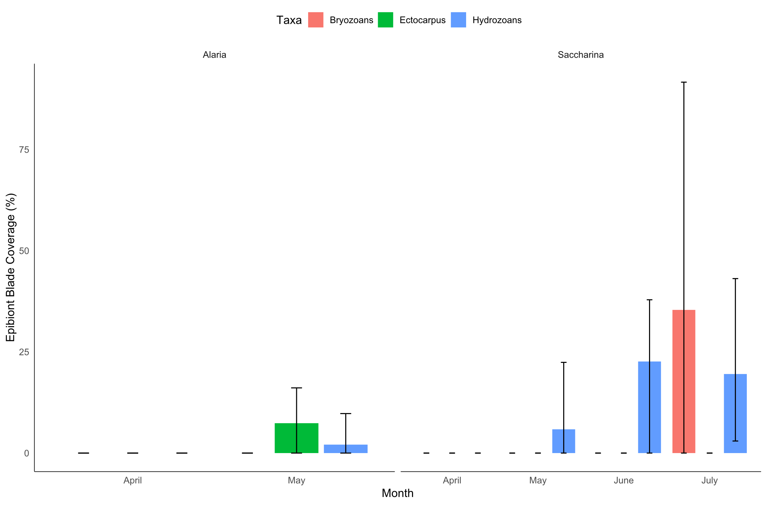

*Figure 8. Bar charts showing mean percent blade surface covered by three epibiont groups—Bryozoans (red), Ectocarpus (green), and Hydrozoans (blue)—from April through July 2022. Error bars extend from the minimum to maximum observed coverage across replicate fronds. Alaria fouling only recorded in May (no June or July data available), whereas Saccharina exhibited negligible coverage in April–May followed by substantial hydrozoan and bryozoan colonization in June–July.*

In Alaria, measurable fouling was detected only in May, when hydrozoan coverage reached approximately 5% and Ectocarpus covered up to ~10% of the blade surface. No bryozoan colonisation was observed on Alaria during the study period although sampling for this species was only possible between January and May.

In contrast, Saccharina fronds exhibited a clear fouling pulse later in the season. Coverage remained negligible through April, but by June hydrozoans reached mean coverage of ~20%, closely followed by a sharp July peak in bryozoan coverage exceeding 35% on average, with some fronds approaching complete encrustation (>80%). Hydrozoan coverage remained high in July (~20%), while Ectocarpus was absent from Saccharina throughout the sampling window.

*Biofouling blade colonisation of Alaria and Saccharina*

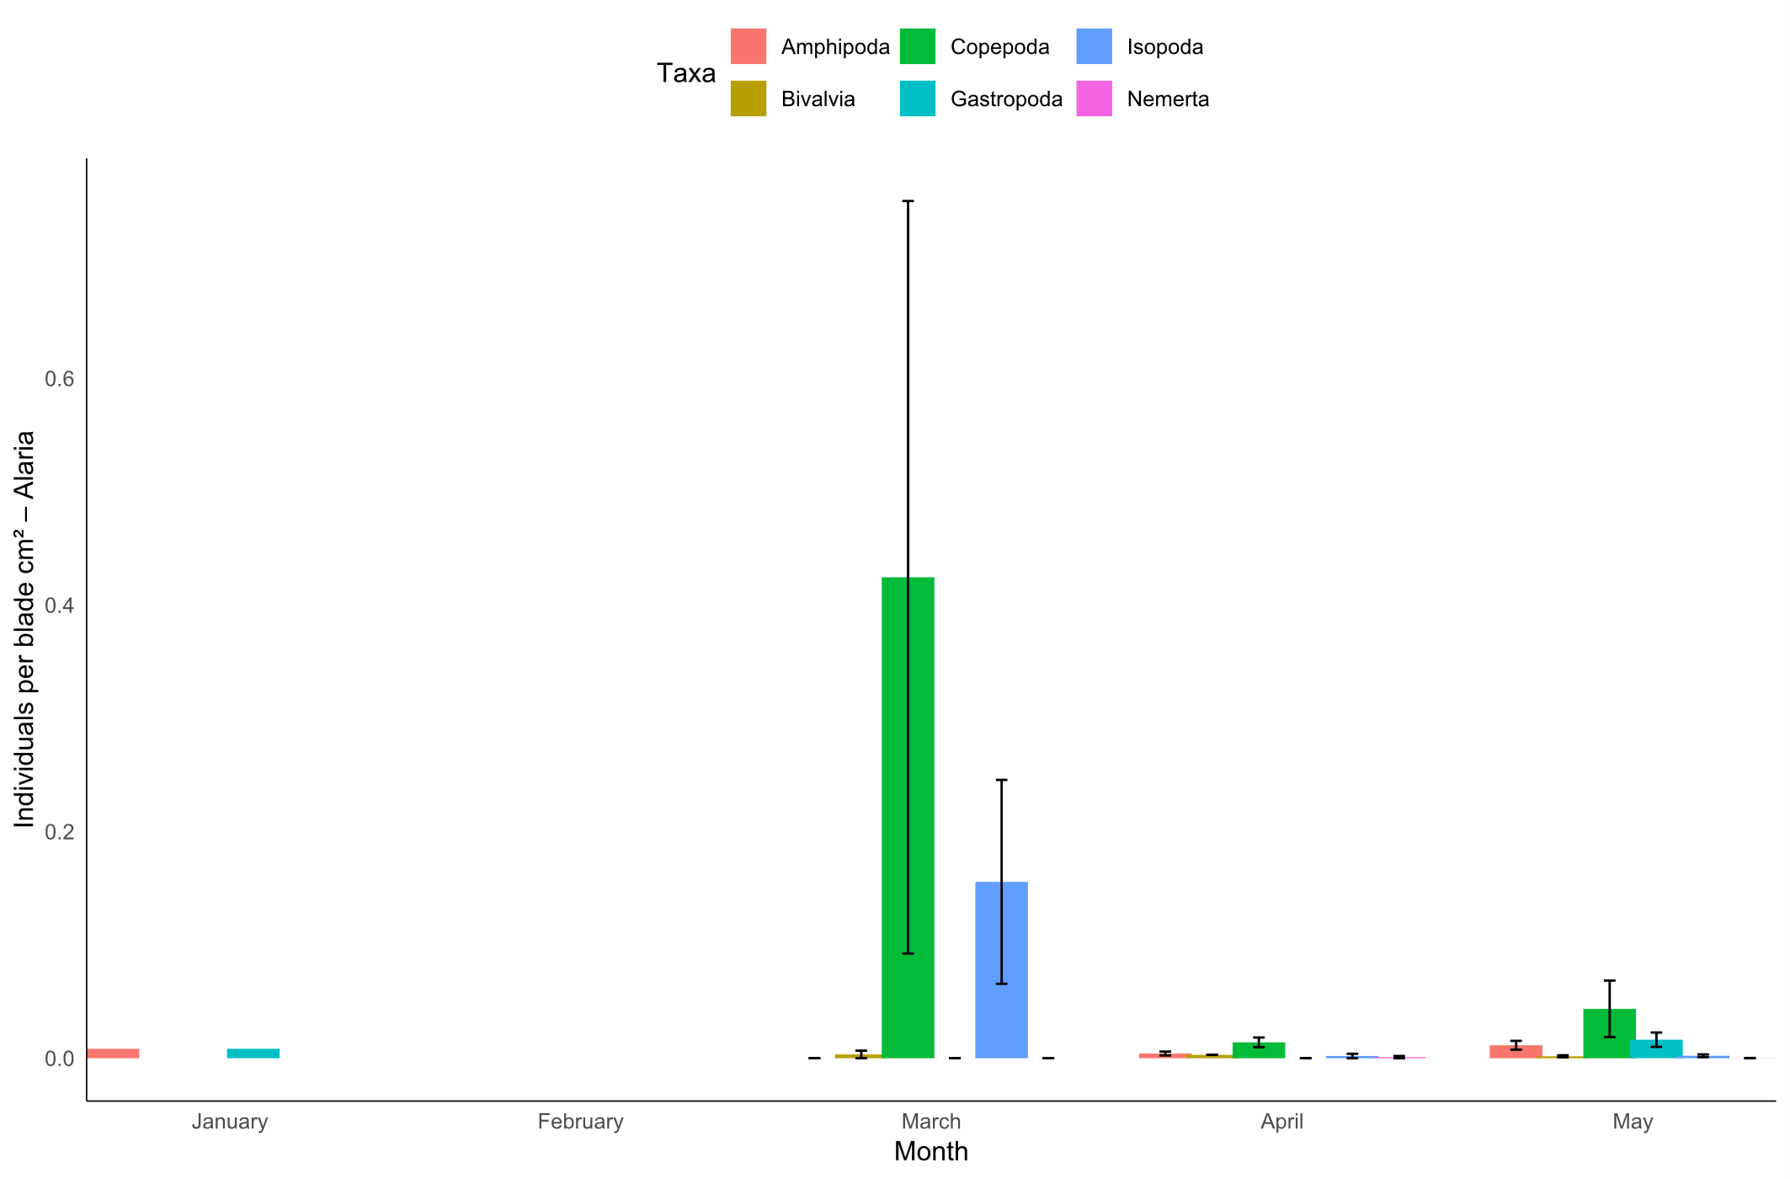

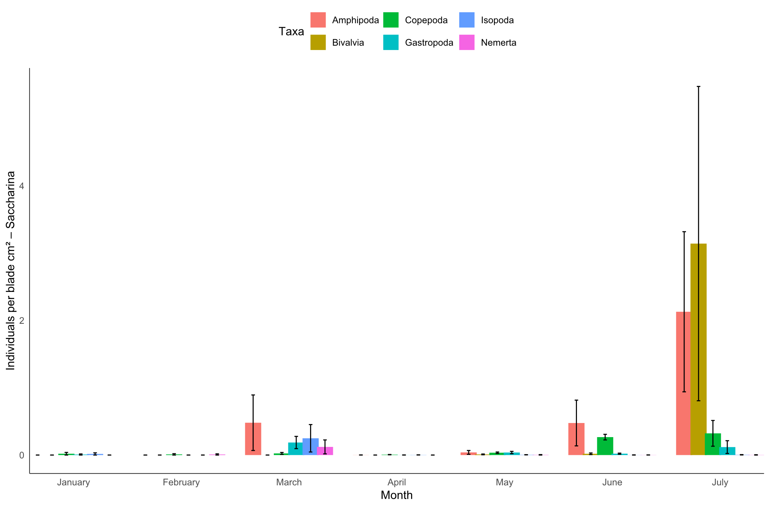

*Figure 9. Bar charts showing mean colonization density (individuals /cm²) of six major taxa—Amphipoda (red), Copepoda (green), Isopoda (blue), Bivalvia (gold), Gastropoda (teal), and Nemertea (magenta)—on Alaria (top) and Saccharina (bottom) fronds from January to July 2022. Error bars span the minimum to maximum values among replicate fronds. On Alaria, peak copepod and isopod settlement occurs in March, with negligible densities before and after; on Saccharina, low-level settlement from January–June is followed by more pronounced amphipod and bivalve colonization in July.*

In Alaria, colonisation densities were generally low throughout the sampling period, with a distinct peak in March driven by elevated copepod (~0.42 ind./cm²) and isopod (~0.18 ind./cm²) settlement. All other taxa occurred at negligible densities (<0.02 ind./cm²) across the season, and no further increases were observed after March.

In Saccharina, colonisation was initially low from January through June, with densities for most taxa remaining below 0.2 ind./cm². From late June into July, settlement intensity increased sharply, dominated by amphipods (~3.5 ind./cm²) and bivalves (~2.8 ind./cm²), alongside smaller contributions from gastropods, copepods, and isopods. Nemerteans were detected sporadically at very low densities (<0.05 ind./cm²) throughout the sampling window.

*Depth effect on epibiont distribution on seaweed fronds*

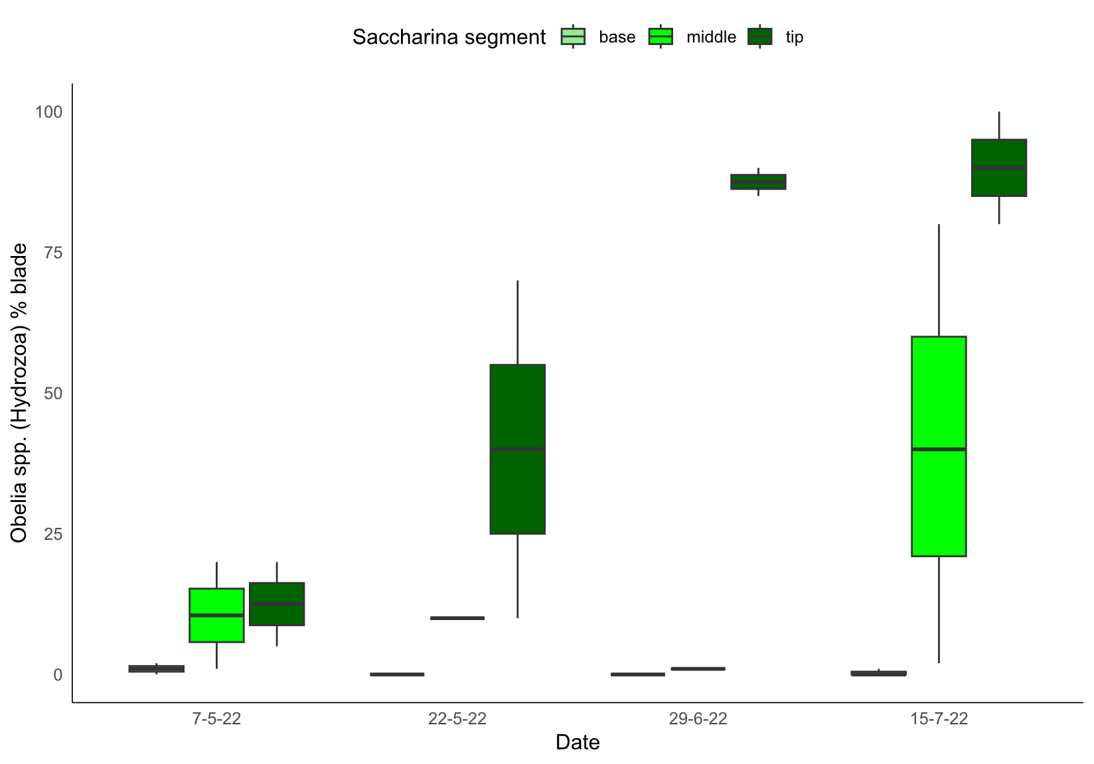

*Figure 10. Boxplots of the percentage of blade area covered by Obelia spp. (Hydrozoa) on three blade segments—base (light green), middle (green), and tip (dark green)—sampled on 7 May, 22 May, 29 June and 15 July 2022. Colonization was essentially zero on the basal segment throughout the season, appeared first and most moderately on the mid‐blade by late May (median ~12 %), and quickly surged on the tip segment, rising from ~30 % coverage in late May to >85 % by late June and nearly complete (>90 %) by mid‐July. This pattern highlights both the rapid seasonal increase in hydrozoan fouling and the strong depth‐related gradient of epibiont settlement along the kelp blade.*

Two-way ANOVA showed that hydrozoan coverage was significantly influenced by blade segment depth (F₂,₁₉ = 12.93, *p* < 0.001) and varied significantly across sampling dates (F₃,₁₉ = 3.44, *p* < 0.05). Across all sampling dates, hydrozoan coverage on the basal blade segment remained negligible (<2%), indicating minimal settlement in this zone. The mid-blade segment showed low but detectable colonisation in early May (~10–15%), which increased steadily to median values around 40% by mid-July. In contrast, the tip segment displayed both earlier and more intense fouling. By late May, coverage already exceeded 30%, rising sharply to >85% by late June and reaching near-complete encrustation (>90%) by mid-July. This consistently higher colonisation at the blade tip compared to mid and basal segments reflects a strong depth‐related gradient in settlement intensity. Overall, these data show that hydrozoan colonisation of Saccharina fronds follows a distinct vertical pattern, with the oldest, most distal tissue supporting the earliest and densest settlement, and younger basal tissue remaining largely unafflicted throughout the season.

**Discussion**

As the first of its kind study, we aligned eDNA metabarcoding, DNA barcoding, plankton microscopy and blade surveys across a full kelp production cycle to directly compare detection capacities and temporal resolutions. eDNA was demonstrated to be a powerful early-warning tool in detecting key epibionts weeks before observation by plankton microscopy, and up to two months before colonisation on kelp fronds. This pattern was most evident in Hydrozoans, where eDNA signals peaked in March and April, followed by elevated plankton counts in May and June and subsequent blade coverage maximums in July (Fig. 3). These detection lags indicate a predictable seasonal window of infestation risk, with *Saccharina latissima* proving greater susceptibility to blade colonisation relative to *Alaria esculenta* (Fig. 8 and 9)*.* However, Fig. 10 demonstrates eDNA to less effective in detecting and recovering temporal patterns of problematic bivalve species compared with gross microscopic analysis at the class level. Relative to light microscopy surveys, DNA barcoding (COI) and eDNA metabarcoding provided far higher taxonomic resolution of cryptic and early-stage species, notably *Bougainvillia muscus*, *Clytia hemisphaerica*, *Jassa herdmani* and *Hiatella arctica* (Table. 1). Overall, plankton microscopy was only able to allocate taxa to the level of class or order while molecular tools identified to the species level (Table. 1). Rope scrubs confirmed presence of epibionts on farm infrastructure suggesting potential reservoirs/vectors for fouling activity (Table. 1). Comparisons of depth-related settlement patterns showed hydrozoan (*Obelia spp.*) fouling intensity to be significantly greater on blade tips which is positioned deepest in the water column, while basal regions remained largely free from fouling (Fig. 10).

*Enhanced taxonomic resolution via barcoding*

Barcoding provided improved accuracy in epibiont identification relative to conventional morphological microscopy, generating species-level resolution for groups that were otherwise indistinguishable. For example, several specimens were microscopically identified simply as “hydroids,” which would have grouped them collectively. However, COI barcoding confidently resolved them into distinct species including *Ectopleura larynx*, *Bougainvillia muscus*, and *Clytia hemisphaerica* (Table 1). Conversely, there were cases where microscopy classified multiple specimens as separate taxa, but barcoding revealed them to be the same species, e.g. *B. muscus* (Table 1). These findings highlight the inherent challenges of morphology-based identification that DNA barcoding overcomes. In particular, hydroids and bryozoan stages are often small, cryptic or morphologically similar making them notoriously difficult to identify to species level microscopically (Lee et al., 2011, Schuchert, 2020).

The barcode identification of epibionts on rope infrastructure followed by their observed colonisation on kelp fronds is significant, as it indicates that ropes may serve as reservoirs until fronds reach a suitable size for settlement. As ropes often remain submerged year-round, they may serve as persistent sources of larvae, facilitating colonisation once blade surfaces reach surface suitability. This vector role of infrastructure in biofouling dynamics is previously reported in shellfish and salmon operations and suggests that farms could benefit from proactive rope management, such as cleaning, air exposure or chemical/heat treatment prior to seeding to mitigate latter infestation (Sievers et al., 2019, Hopkins et al., 2021) .

*Temporal lags between eDNA, plankton, and blade settlement*

Temporal lag strucutres between sampling methods did emerge with eDNA signals being detected first, followed by plankton counts and finally blade settlement survey. Of the taxa examined, hydrozoans showed the most pronounced eDNA peaks between March and April largely attributed to *Clytia sp. 2* and *Bougainvillia muscus* (Fig. 3). This was followed by microscopy maxima in May/June, followed by extensive colonisation *Saccharina* fronds in July, with some fronds exceeding 85% coverage (Fig. 3). Bryozoans showed a similar though slightly less pronounced lag, with eDNA signals of *Celleporella hyalina* appearing concurrently with elevated cyphonautes counts, which then rose sharply only a few weeks before blade coverage reached its peak. Temporal offsets were most evident in hydrozoans and bryozoans which are known to exhbit strong seasonal recruitment pulses within temperate climates suggested to be driven by seasonal temperature and photoperiodic cues (Saunders and Metaxas, 2009, Forbord et al., 2020). This illustrates the applicability of molecular tools for early-warning of infestation onset. In this case, providing a window of opportunity lasting several weeks to months where intervention management strategies such as selective harveting could be implemented to fully avoid fouling onset (Bannister et al., 2019).

The strength of seasonal lags between methods differed among taxonomic groups. Overall, gastropods and bivalves showed weaker or less consistent temporal lags between method types and instead showed synchrony between eDNA, plankton and blade signals, particulalry for *Alaria* samples (Figs. 4 and 6). This may be result of the more prolonged or opportunistic recruitement dynamics that these taxa employ as opposed to defined seasonal pulses. Settlement studies have shown that bivalves such as *Mytilus edulis* can spawn repeatedly over extended periods, with settlement occurring continuously throughout the year (Garcia et al., 2003). Consistent with this study, plankton microscopy indicated that bivalve larvae were present during much of the study period, although this was not reflected in the eDNA dataset (Fig. 4). This life-history traits help explain the lack of clear sequential phases across methods for bivla\ves, in contrast to the more seasonally pulsed recruitment observed in hydrozoans and bryozoans.

Overall, this suggests that the strength of eDNA as an early-warning tool is greatest for taxa with distinct, seasonally synchronised recruitment events relative to groups with extended or continuous reproduction. Metabarcoding does provides a valuable complementary perspective but does not necessarily extend the temporal resolution offered by microscopy and blade monitoring for all biofouling taxa problematic to seaweed aquaculture.

Among amphipods, *Jassa herdmani* provided one of the clearest examples of a temporal lag structure across methods. eDNA first detected the species in March, followed by a pronounced peak in April. This preceded a distinct rise in planktonic amphipod abundance recorded in microscopy samples in May, and ultimately culminated in substantial blade colonisation on *Saccharina* in late July which was confirmed cia COI barcoding (Table 1). This stepwise progression highlights the capacity of molecular approaches to identify *J. herdmani* several months before visible fouling occurs on fronds. Furthermore, *Alaria* fronds exhibited earlier but lower-intensity colonisation in May, whereas *Saccharina* supported a later yet considerably denser infestation, suggesting differences in host-specific susceptibility and timing of amphipod settlement. Other amphipod detections, including Caprellidae and Gammaridae, were observed on fronds but not identified through eDNA which suggests either low eDNA shedding or database limitations.

Although not distinctly identified by plankton microscopy, the eDNA dataset revealed presence of larvae or free-floating DNA from the gastropod nudibranch *Doto coronata*, a known predator of hydroids, including those of the genus *Clytia (Martinsson et al., 2021).* Here, *D. coronata,* was detected in in March eDNA samples concurrent with *Clytia sp.* signals (Fig. 3 and 5). This co-occurrence implies that predator-prey interactions may already be shaping early-stage biofouling communities. Trophic dynamics such as these are difficult to capture though visual techniques but can be inferred from molecular approaches, highlighting their potential in not only revealing fouling taxa diversity but also their ecological relationships.

Overall, the integration of methods revealed both clear alignment and important mismatches, underscoring the strengths of eDNA for early detection and taxonomic specificity as well as highlight the complementary value of microscopy and blade surveys in confirming physical presence and quantifying settlement intensity.

*eDNA vs microscopy – detection efficiency and mismatches*

This mirrors findings from a comparable study of fouling communities on settlement plates in a Portuguese port where metabarcoding consistently outperformed morphological identification, providing a far greater diversity of taxa and highlighting cryptic species that microscopy overlooked (Azevedo et al., 2020). Although the degree of improvement varied across groups, metabarcoding consistently provided substantially higher taxonomic resolution than microscopy. For hydrozoans, eDNA resolved 25 distinct taxa, whereas microscopy identified only the broad class “Hydrozoa”. (Fig. 3). A similar contrast was seen for gastropods, with microscopy limited to class-level larvae while eDNA detected 22 individual species (Fig. 6). In comparison, bryozoans, bivalves, and amphipods yielded more modest results, with eDNA detecting only 3–4 species per group beyond the broader microscopic findings (Figs. 2,4 and 5). These differences may reflect the true diversity of the sampled communities however more likely illustrate the relative completeness of available barcode reference databases utilised for COI which appear more comprehensive for hydrozoans and gastropods than for the other taxa. This underscores the urgent need for a more taxonomically comprehensive COI reference database for global zooplankton, which would greatly enhance the accuracy of eDNA and barcoding approaches and strengthen their value across fisheries management, climate change monitoring, and broader ecological research (Bucklin et al., 2021, Keck et al., 2022).

A recurring feature within the molecular dataset was the presence of dropouts, instances where a species produced a strong eDNA signal in one sampling month but then failed to be detected in subsequent months despite its continued observation via microscopy. For example, bryozoan cyphonautes were consistently recorded microscopically between September and March and again from midsummer onwards (Fig. 2). In contrast, eDNA signals for key bryozoans such as *Electra pilosa* *and Membranipora membranacea* peaked in autumn and spring but were intermittently absent at other times, including periods when plankton counts remained high and blade coverage reached its maximum in late July (Fig.2). At the point when colonies reached their highest coverage, it would be expected that processes such as shedding, tissue decay, and DNA release from sloughing would generate abundant genetic material in the surrounding water, making these taxa readily detectable by eDNA. The absence of a molecular signal during this period, despite high levels of visible fouling underscores the problem of dropouts and infers methodological limitations. For example, the lack of and effective universal primer across a diverse phyla range can cause amplification biases leading to these detection inconsistencies (Borrell et al., 2017). A recent study on planktonic threats in salmon aquaculture reported comparable discrepancies between microscopic and molecular approaches, with metabarcoding showing limited predictive capacity for organismal abundance and considerable variation in detection sensitivity (Algueró‐Muñiz et al., 2024). The authors also reported that each method identified species that the other failed to detect, underscoring the limitations and complementarity of both visual and molecular diagnostics (Algueró‐Muñiz et al., 2024). Robustness of molecular data can be improved by employing multiple genetic markers simultaneously which has proven effective in minimising primer-driven taxonomic bias and improving detection sensitivity of small or cryptic organisms, a recognised limitation in metabarcoding studies (Azevedo et al., 2020, Algueró‐Muñiz et al., 2024).

*Host-specific susceptibility*

It is well established that the bryozoans cause major issues for the northeast Atlantic seaweed industry with encrusting colonies causing tissue necrosis and reducing harvestable biomass (Forbord et al., 2020, Førde et al., 2015). *Saccharina* *latissima* infestation showed an explosive increase in coverage, rising from negligible levels in June to approximately 90% coverage on some fronds by July (Fig.8). The rapid increase in coverage highlights a clear tipping point in colonisation dynamics between initial observable settlement and severe infestation. Known environmental drivers of bryozoan growth include rising summer temperature and hydrodynamic conditions (Saunders and Metaxas, 2007). Although environmental data were beyond the scope of this study, it is likely that seasonal temperature increases contributed to the observed fouling maxima. These results are consistent within findings from Norwegian cultivation sites, where *Saccharina* also exhibited sharp increases in bryozoan cover in late June and July. The authors reported colony densities varying between sites with different farm stocking density, with higher seaweed densities likely driving local spawning and recruitment from pre-existing colonies (Yoshioka, 1982, Førde et al., 2015). At the Skye study site, peak seaweed biomass in July may similarly have facilitated rapid bryozoan settlement. While microscopy did not resolve species identity on fronds, the detection of *Membranipora membranacea*, *Electra pilosa*, and *Celleporella hyalina* through eDNA and COI barcoding aligns with expectations, as these are well-established biofouling taxa for the region (Hermansen et al., 2001, Rouse et al., 2013).

Interestingly, between the two cultivated kelp species examined, only *Saccharina latissima* showed signs of bryozoan colonisation (Fig. 2). This may suggest a degree of host-specific susceptibility, with *Saccharina* providing a more favourable substrate than *Alaria esculenta*. This pattern is consistent with earlier observations by (Ryland, 1962) who reported *M. membranacea* exhibiting preference for laminarian hosts (e.g. *S. latissima*), whereas *E. pilosa* is less selective and frequently colonises hard substrates such as rocks and shells. However, in this study *Alaria* was only sampled until May, before bryozoan colonies typically appear on fronds and any apparent resistance may therefore be likely an artefact of sampling constraints.

*Depth effect on epibiont distribution on seaweed fronds*

This suggests that sugar kelp biofouling activity by *Obelia sp.* is driven by depth and time. This may be due to colonisation being favoured by a more stable water column microenvironment. For example, reduced light penetration, turbulence and potentially higher nutrient availability may contribute to hydrozoan proliferation. Segments deeper in the water column would have less mechanical disturbance from wave action further enabling sustained polyp growth.

Furthermore, seaweed growth occurs as the base/meristem while older tissue at the tips continually sheds (Mann, 1973). The distal blade segment represents the oldest, most established surface. The increased colonisation at the tip may be resultant from the tissue being more withered or structurally compromised due to longer exposure to environmental stressors thus heightening susceptibility to infestation. More simply, the tip section of the frond has existed the longest and therefore has had the greatest exposure time, providing more opportunities for settlement events and colony expansion. These combined physical and biological factors offer a plausible explanation for the consistently higher levels of biofouling observed at the blade tips. However, further targeted investigation is needed to disentangle the relative contribution of each factor and determine whether a single dominant driver or a synergistic combination is primarily responsible for hydrozoan colonisation patterns.

Biofouling represents a major bottleneck within kelp aquaculture; limiting yields, compromising sustainability and ultimately limiting long-term viability of farms operations (Bannister et al., 2019, Walls et al., 2017). Advancing methods of early detection of problem epibionts within farm-management strategies will provide farmers with an opportunity to incorporate pro-active measures to improve sustainability and mitigate infestation before infestation reaches economically damaging levels. This work demonstrates aligning complementary molecular and microscopy methods not only strengthens understanding of biofouling dynamics but also provides powerful risk awareness to safeguard farm productivity.

**References**

ALGUERÓ‐MUÑIZ, M., SPATHARIS, S., DWYER, T., DE NOIA, M., CHEAIB, B., LIU, YEE W., ROBERTSON, BRENDAN A., JOHNSTONE, C., WELSH, J., MACPHEE, A., MAZURKIEWICZ, M., BICKERDIKE, R., MIGAUD, H., MCGHEE, C., PRÆBEL, K. & LLEWELLYN, M. 2024. High‐Resolution Longitudinal eDNA Metabarcoding and Morphological Tracking of Planktonic Threats to Salmon Aquaculture. *Environmental DNA,* 6.

AZEVEDO, J., ANTUNES, J. T., MACHADO, A. M., VASCONCELOS, V., LEAO, P. N. & FROUFE, E. 2020. Monitoring of biofouling communities in a Portuguese port using a combined morphological and metabarcoding approach. *Sci Rep,* 10**,** 13461.

BANNISTER, J., SIEVERS, M., BUSH, F. & BLOECHER, N. 2019. Biofouling in marine aquaculture: a review of recent research and developments. *Biofouling,* 35**,** 631-648.

BORRELL, Y. J., MIRALLES, L., DO HUU, H., MOHAMMED-GEBA, K. & GARCIA-VAZQUEZ, E. 2017. DNA in a bottle-Rapid metabarcoding survey for early alerts of invasive species in ports. *PLoS One,* 12**,** e0183347.

BUCKLIN, A., PEIJNENBURG, K. T. C. A., KOSOBOKOVA, K. N., O’BRIEN, T. D., BLANCO-BERCIAL, L., CORNILS, A., FALKENHAUG, T., HOPCROFT, R. R., HOSIA, A., LAAKMANN, S., LI, C., MARTELL, L., QUESTEL, J. M., WALL-PALMER, D., WANG, M., WIEBE, P. H. & WEYDMANN-ZWOLICKA, A. 2021. Toward a global reference database of COI barcodes for marine zooplankton. *Marine Biology,* 168.

DELANNOY, V., ALGUERÓ‐MUÑIZ, M., CHRISTOFOROU, E., HADDOU, Y., MACPHEE, A., MCEACHNIE, K., ORR, K. & SPATHARIS, S. 2025. Large‐Scale Environmental Drivers of Kelp Biofouling Based on Literature Data. *Reviews in Aquaculture,* 17.

DJURHUUS, A., PORT, J., CLOSEK, C. J., YAMAHARA, K. M., ROMERO-MARACCINI, O., WALZ, K. R., GOLDSMITH, D. B., MICHISAKI, R., BREITBART, M., BOEHM, A. B. & CHAVEZ, F. P. 2017. Evaluation of Filtration and DNA Extraction Methods for Environmental DNA Biodiversity Assessments across Multiple Trophic Levels. *Frontiers in Marine Science,* 4.

DUARTE, S., SIMOES, L. & COSTA, F. O. 2023. Current status and topical issues on the use of eDNA-based targeted detection of rare animal species. *Sci Total Environ,* 904**,** 166675.

FORBORD, S., MATSSON, S., BRODAHL, G. E., BLUHM, B. A., BROCH, O. J., HANDÅ, A., METAXAS, A., SKJERMO, J., STEINHOVDEN, K. B. & OLSEN, Y. 2020. Latitudinal, seasonal and depth-dependent variation in growth, chemical composition and biofouling of cultivated Saccharina latissima (Phaeophyceae) along the Norwegian coast. *Journal of Applied Phycology,* 32**,** 2215-2232.

FØRDE, H., FORBORD, S., HANDÅ, A., FOSSBERG, J., ARFF, J., JOHNSEN, G. & REITAN, K. I. 2015. Development of bryozoan fouling on cultivated kelp (Saccharina latissima) in Norway. *Journal of Applied Phycology,* 28**,** 1225-1234.

GARCIA, E. G., THORARINSDOTTIR, G. G. & RAGNARSSON, S. A. 2003. Settlement of bivalve spat on artificial collectors in Eyjafjordur, North Iceland. *Hydrobiologia,* 503**,** 131-141.

HERMANSEN, P., LARSEN, P. S. & RIISGÅRD, H. U. 2001. Colony growth rate of encrusting marine bryozoans (Electra pilosa and Celleporella hyalina). *Journal of Experimental Marine Biology and Ecology,* 263**,** 1-23.

HOPKINS, G., DAVIDSON, I., GEORGIADES, E., FLOERL, O., MORRISEY, D. & CAHILL, P. 2021. Managing Biofouling on Submerged Static Artificial Structures in the Marine Environment – Assessment of Current and Emerging Approaches. *Frontiers in Marine Science,* 8.

JAGTAP, A. S. & MEENA, S. N. 2022. Seaweed farming: A perspective of sustainable agriculture and socio-economic development. *Natural Resources Conservation and Advances for Sustainability.*

JUETERBOCK, A., HOARAU-HEEMSTRA, H., WIGGER, K., DUARTE, B., BRUCKNER, C., CHAPMAN, A., DUAN, D., ENGELEN, A., GAUCI, C., HILL, G., HU, Z.-M., KHANAL, P., KHATEI, A., MACKINTOSH, A., MELAND, H., MELO, R., NILSEN, A. M. L., OLSEN, L., RAUTENBERGER, R., REISS, H. & ZHANG, J. 2025. Roadmap to sustainably develop the European seaweed industry. *npj Ocean Sustainability,* 4.

KECK, F., BLACKMAN, R. C., BOSSART, R., BRANTSCHEN, J., COUTON, M., HURLEMANN, S., KIRSCHNER, D., LOCHER, N., ZHANG, H. & ALTERMATT, F. 2022. Meta-analysis shows both congruence and complementarity of DNA and eDNA metabarcoding to traditional methods for biological community assessment. *Mol Ecol,* 31**,** 1820-1835.

KRUMHANSL, K. A., LEE, J. M. & SCHEIBLING, R. E. 2011. Grazing damage and encrustation by an invasive bryozoan reduce the ability of kelps to withstand breakage by waves. *Journal of Experimental Marine Biology and Ecology,* 407**,** 12-18.

LEE, H.-J., KWAN, Y.-S., KONG, S.-R., MIN, B.-S., SEO, J.-E. & WON, Y.-J. 2011. DNA Barcode Examination of Bryozoa (Class: Gymnolaemata) in Korean Seawater. *Animal Systematics, Evolution and Diversity,* 27**,** 159-163.

MANN, K. 1973. Seaweeds: Their Productivity and Strategy for Growth: The role of large marine algae in coastal productivity is far more important than has been suspected. *Science,* 182**,** 975-981.

MARTELL, L., BRACALE, R., CARRION, S. A., GIANGRANDE, A., PURCELL, J. E., LEZZI, M., GRAVILI, C., PIRAINO, S. & BOERO, F. 2018. Successional dynamics of marine fouling hydroids (Cnidaria: Hydrozoa) at a finfish aquaculture facility in the Mediterranean Sea. *PLoS One,* 13**,** e0195352.

MARTINSSON, S., MALMBERG, K., BAKKEN, T., KORSHUNOVA, T., MARTYNOV, A. & LUNDIN, K. 2021. Species delimitation and phylogeny of

Doto (Nudibranchia: Dotidae) from the Northeast Atlantic, with a discussion on food specialization. *Journal of Zoological Systematics and Evolutionary Research,* 59**,** 1754-1774.

MATSSON, S., CHRISTIE, H. & FIELER, R. 2019. Variation in biomass and biofouling of kelp, Saccharina latissima, cultivated in the Arctic, Norway. *Aquaculture,* 506**,** 445-452.

RISHAN, S. T., KLINE, R. J. & RAHMAN, M. S. 2023. Applications of environmental DNA (eDNA) to detect subterranean and aquatic invasive species: A critical review on the challenges and limitations of eDNA metabarcoding. *Environmental Advances,* 12.

ROUSE, S., SPENCER JONES, M. E. & PORTER, J. S. 2013. Spatial and temporal patterns of bryozoan distribution and diversity in the Scottish sea regions. *Marine Ecology,* 35**,** 85-102.

RYLAND, J. S. 1962. The Association Between Polyzoa and Algal Substrata. *Journal of Animal Ecology,* 31**,** 331-338.

SAUNDERS, M. & METAXAS, A. 2007. Temperature explains settlement patterns of the introduced bryozoan Membranipora membranacea in Nova Scotia, Canada. *Marine Ecology Progress Series,* 344**,** 95-106.

SAUNDERS, M. I. & METAXAS, A. 2009. Population dynamics of a nonindigenous epiphytic bryozoan Membranipora membranacea in the western North Atlantic: effects of kelp substrate. *Aquatic Biology,* 8**,** 83-94.

SCHUCHERT, P. 2020. DNA barcoding of some Pandeidae species (Cnidaria, Hydrozoa, Anthoathecata). *Revue suisse de Zoologie,* 125**,** 101-127, 27.

SIEVERS, M., DEMPSTER, T., KEOUGH, M. J. & FITRIDGE, I. 2019. Methods to prevent and treat biofouling in shellfish aquaculture. *Aquaculture,* 505**,** 263-270.

SULTANA, F., WAHAB, M. A., NAHIDUZZAMAN, M., MOHIUDDIN, M., IQBAL, M. Z., SHAKIL, A., MAMUN, A.-A., KHAN, M. S. R., WONG, L. & ASADUZZAMAN, M. 2023. Seaweed farming for food and nutritional security, climate change mitigation and adaptation, and women empowerment: A review. *Aquaculture and Fisheries,* 8**,** 463-480.

VEENHOF, R. J., BURROWS, M. T., HUGHES, A. D., MICHALEK, K., ROSS, M. E., THOMSON, A. I., FEDENKO, J. & STANLEY, M. S. 2024. Sustainable seaweed aquaculture and climate change in the North Atlantic: challenges and opportunities. *Frontiers in Marine Science,* 11.

VISCH, W., NYLUND, G. M. & PAVIA, H. 2020. Growth and biofouling in kelp aquaculture (Saccharina latissima): the effect of location and wave exposure. *Journal of Applied Phycology,* 32**,** 3199-3209.

WALLS, A. M., EDWARDS, M. D., FIRTH, L. B. & JOHNSON, M. P. 2017. Successional changes of epibiont fouling communities of the cultivated kelp Alaria esculenta: predictability and influences. *Aquaculture Environment Interactions,* 9**,** 57-71.

YOSHIOKA, P. M. 1982. Predator-induced polymorphism in the bryozoan Membranipora membranacea (L.). *Journal of Experimental Marine Biology and Ecology,* 61**,** 233-242.

ZAIKO, A., SCHIMANSKI, K., POCHON, X., HOPKINS, G. A., GOLDSTIEN, S., FLOERL, O. & WOOD, S. A. 2016. Metabarcoding improves detection of eukaryotes from early biofouling communities: implications for pest monitoring and pathway management. *Biofouling,* 32**,** 671-84.

ZHANG, L., LIAO, W., HUANG, Y., WEN, Y., CHU, Y. & ZHAO, C. 2022. Global seaweed farming and processing in the past 20 years. *Food Production, Processing and Nutrition,* 4.